Class Diagram
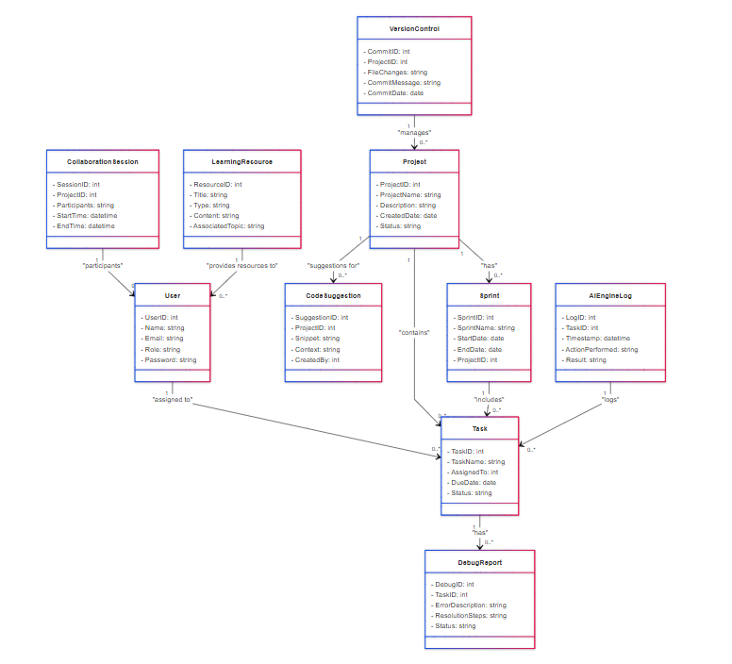
Fig 10.1 Class Diagram

11.Conclusions and References
Conclusions for AI CodeCraft
Smarter Collaboration by Integrating AI
AI CodeCraft has effectively integrated AI-powered features in the form of debugging support and task recommendations that help teams be more productive. Real-time collaboration support allows for smooth collaboration and avoidance of delays due to communication gaps.
User-Centric Design
The project is designed with a user-centric approach, using intuitive dashboards and tools like the Sprint Planning Page and Learning Resources Page. This makes it accessible and usable for a wide variety of users, including developers and project managers.
Iterative and Adaptive Development
Following the Agile methodology, the project was developed in three iterations. This allows continuous feedback incorporation, which enables the adaptive approach to cope with quick changes in user requirements.
Robust Architecture and Scalability
AI CodeCraft is developed using React.js, Node.js, and MongoDB for high scalability and performance. That means the platform will be able to resist increased user demand and complexity of data.
Full Cycle of Testing and Deployment
Employing testing tools such as Jest and Selenium ensured the platform is strong and free from bugs. In each iteration, the system was put to a lot of tests for its reliability before being released.
AI Empowerment
OpenAI APIs empower functionality like debugging assistance and intelligent task assignments that are big value additions and capability enhancements for the platform.
Agile Practices Successfully Deployed
The project demonstrates strong alignment with Agile principles, including well-defined sprints, prioritized backlogs, and efficient task management.

